Old Windsor Parish Council Planning Addendum

APPLICATIONS TO BE CONSIDERED AT THE MEETING HELD ON
TUESDAY 2nd SEPTEMBER 2025
APPLICATIONS

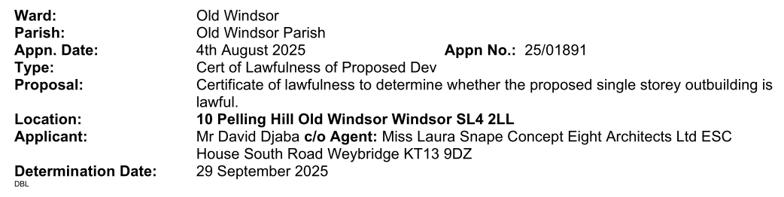

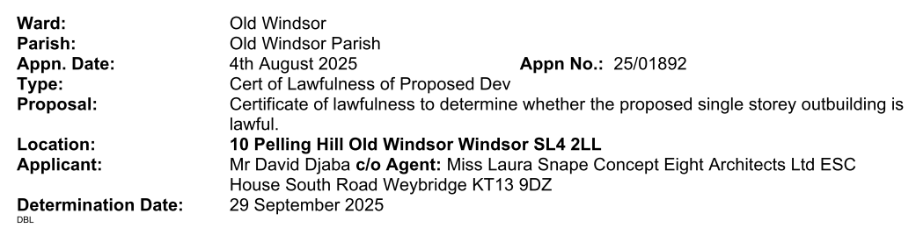

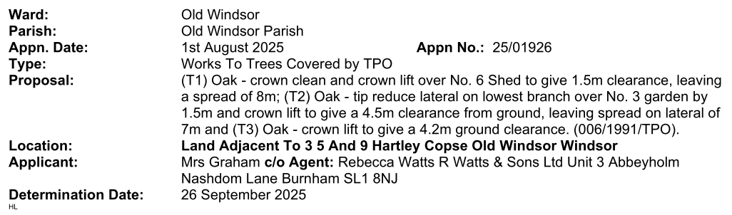

THE PARISH COUNCIL URGES RESIDENTS WHO HAVE STRONG FEELINGS FOR OR AGAINST ANY PLANNING APPLICATION TO MAKE REPRESENTATIONS TO RBWM WHO MAKE THE FINAL DECISION ON ALL PLANNING APPLICATIONS HOWEVER THE ATTENDANCE OF RESIDENTS AND RECEIPT OF THEIR COMMENTS IS PARTICULARLY WELCOMED BY THE PARISH COUNCIL

